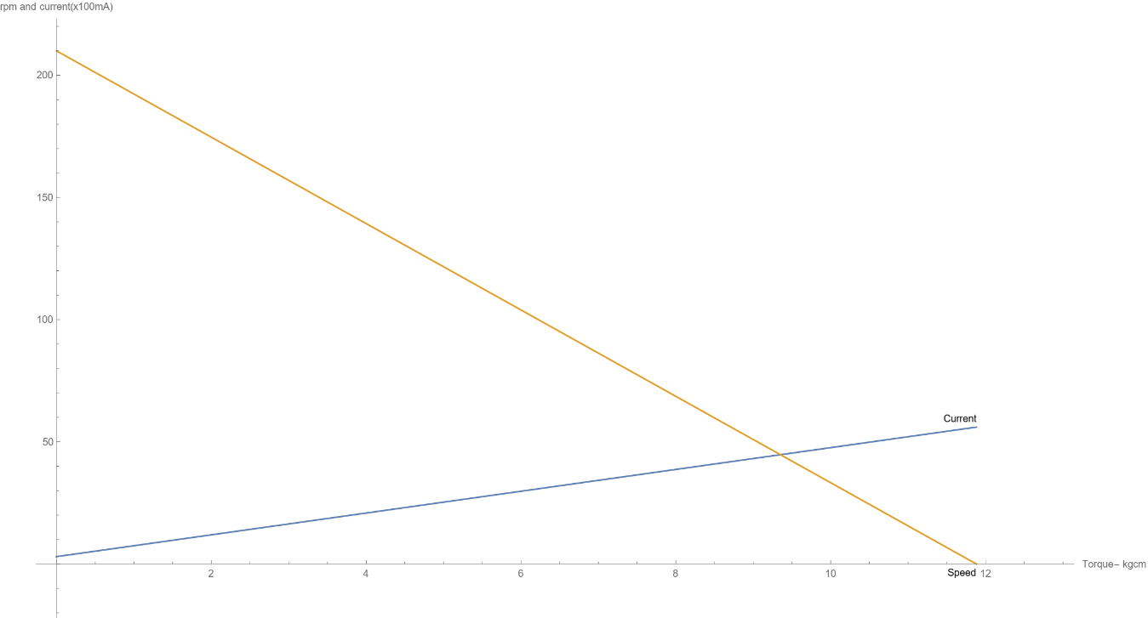

The combined graph shows the relationship the speed of a ____DC motor (in rpm) vs Torque (in kgcm) and the Current drawn by the motor (x100mA) vs Torque (in kgcm). The stall current is about 4200 mA for a 9V supply, with stall Torque of 11.8 kgcm. Load free speed is 210rpm (22 rad/s).

Leaving a safety margin of 25%, the motor will be able to overcome a Torque of 8.8kgcm. If using this motor, the circuit components relating to one motor (such as motor driver) should be capable of handling 4A. For the current to be below 2A(the common limit of an L298), the task and design of the robot should be restricted below (2*11.8/4.2) = 5.6kgcm.

Considering the case where the torque requirement is highest, (start of the ramp climb of 20 degrees)

Torque limit per motor = 5.6kgcm

Torque by two motors = 11.2kgcm

Taking radius of the wheel as 3cm, Force provided along the inclination = (3x11.2x9.8) =329N

Load it can support vertically = (329 sin (20) / 9.8) = 11.4kg.

The speed of motor at 5.6kgcm torque = (1- 2/4.2) *22 = 11.5 rad/s, which gives a speed of 0.34m/s along the ramp.

Thus, if this motor is used at a load significantly less than 11.4kg, then we can be confident that currents of 2A will not be exceeded. A smaller load would reduce the torque required, current drawn will reduce, and higher speeds can be achieved.